**Use Case prototypes**

Narrative: These prototypes represent the page that the user will interface with to complete each user case. They are incomplete models, but do represent a high-level view of what elements will be found on the page.

1. Finding Information – User is able to access information

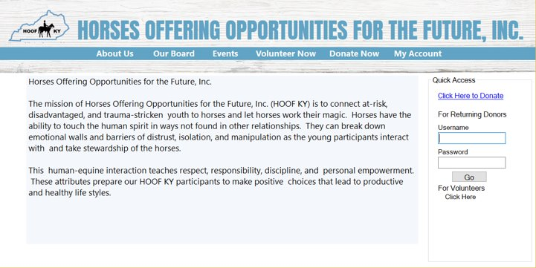

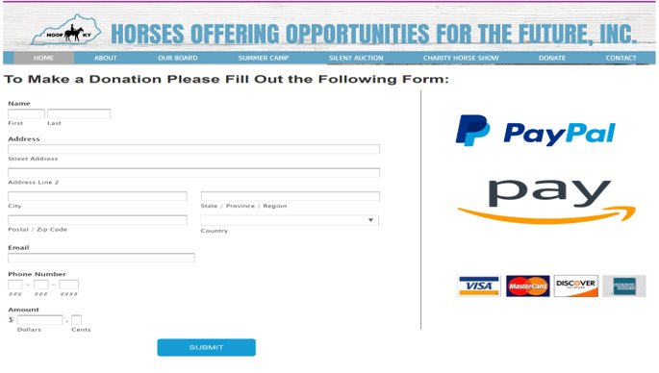

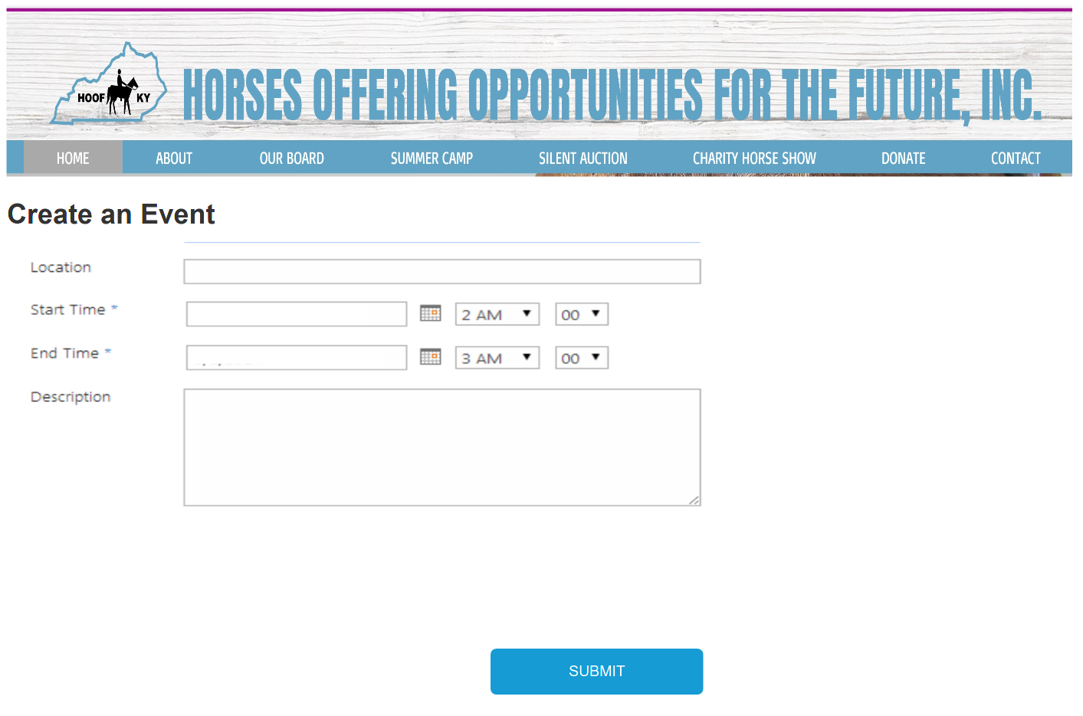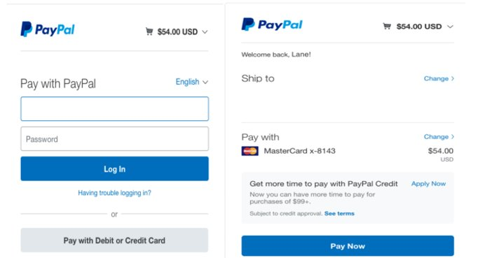

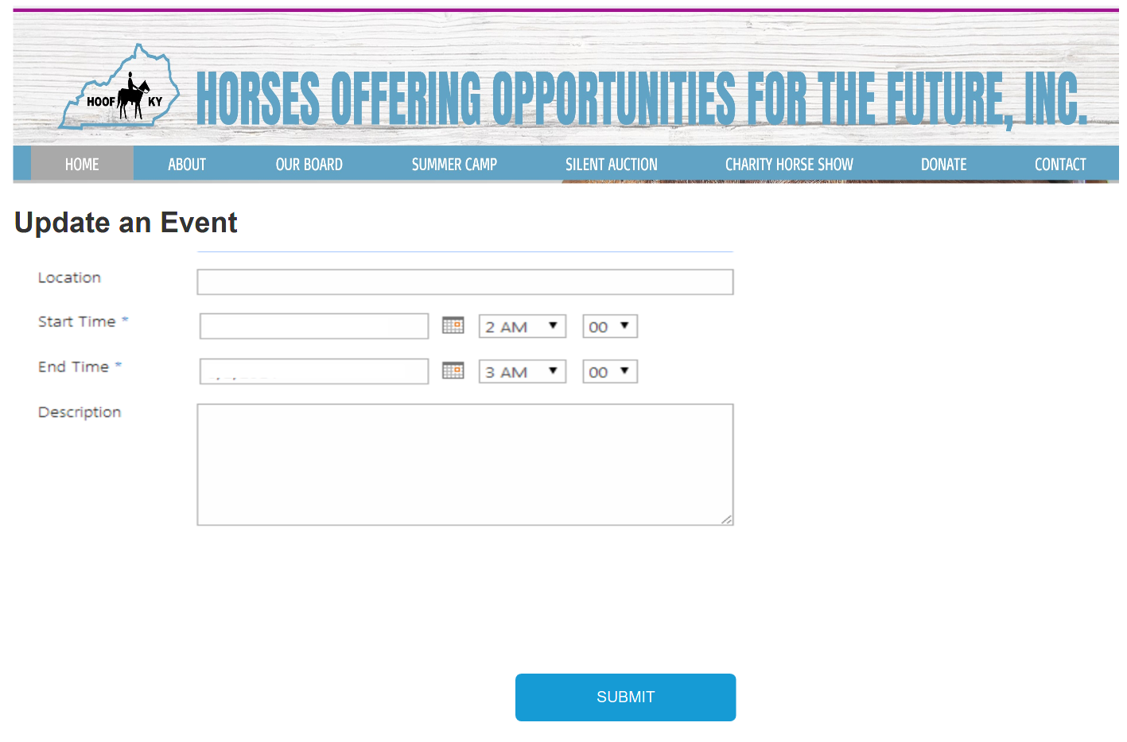

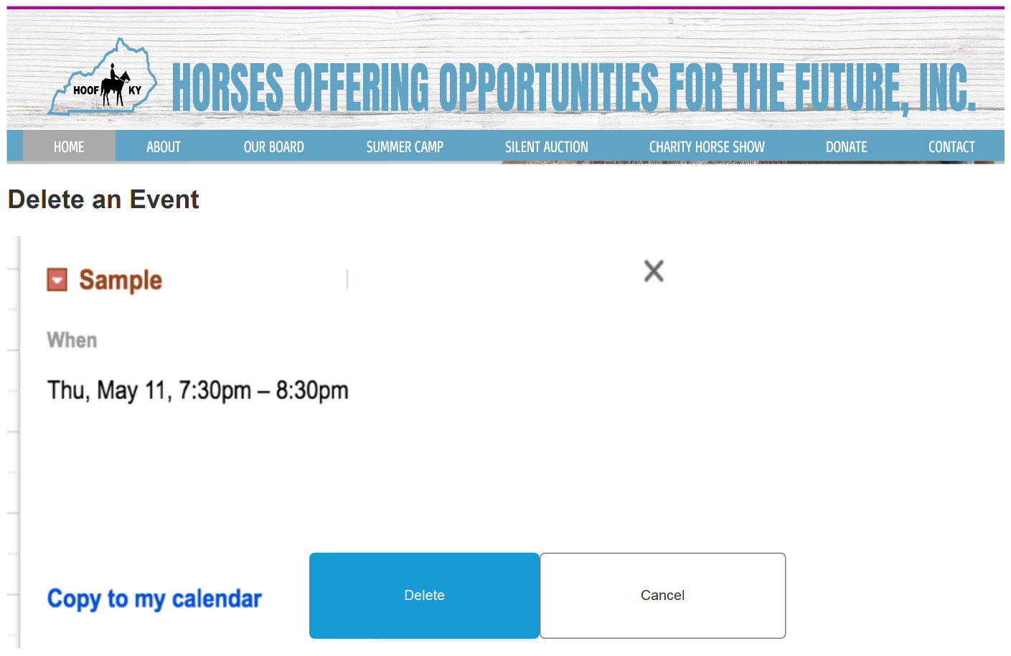

Donors entering information. After hitting the submit button, the system will also store the donor’s information.

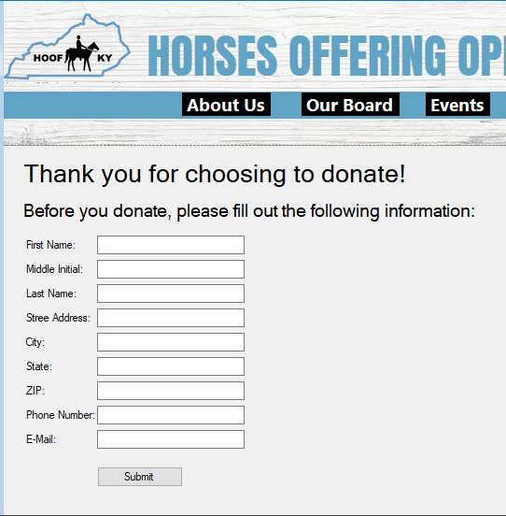

The next prototype is very similar, but it is for a donor that already that has an account and wishes to change any information previously entered or if they wish to delete the account.

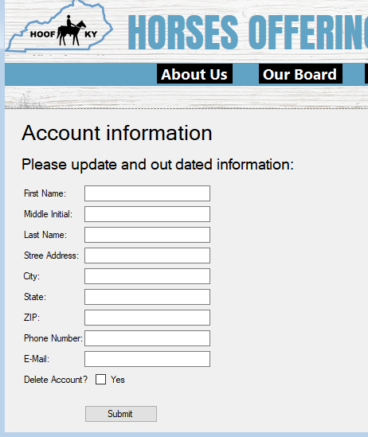

This Prototype is showing you how the system will store any files you may want to save to the database. You can also select "open” to modify any of the system stores or “delete” to delete to delete anything from the database.

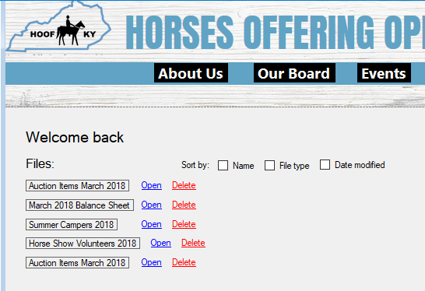

40: Enter Camper

Narrative: This screen is where the nominator will enter the camper’s information and their own information.

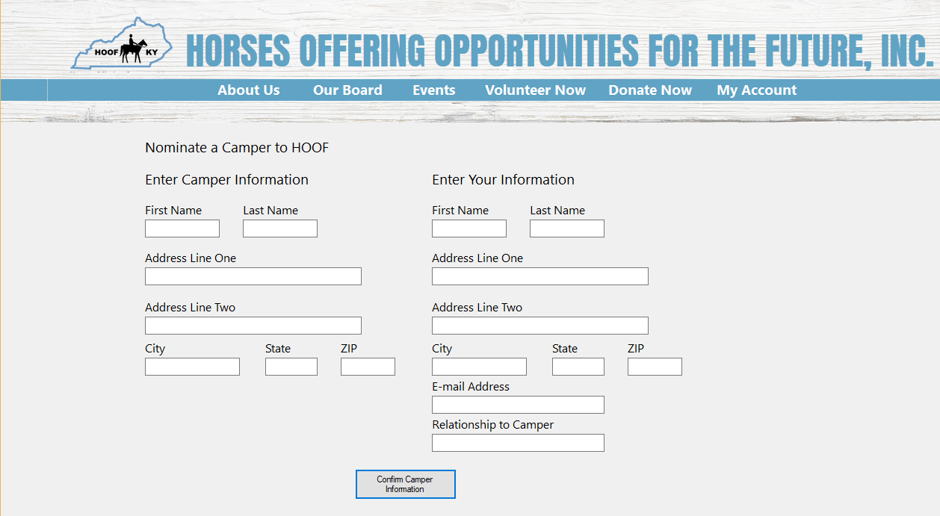

41: Delete Camper Registration

This screen is where the parent/guardian will be able to cancel their child’s nomination to HOOF.

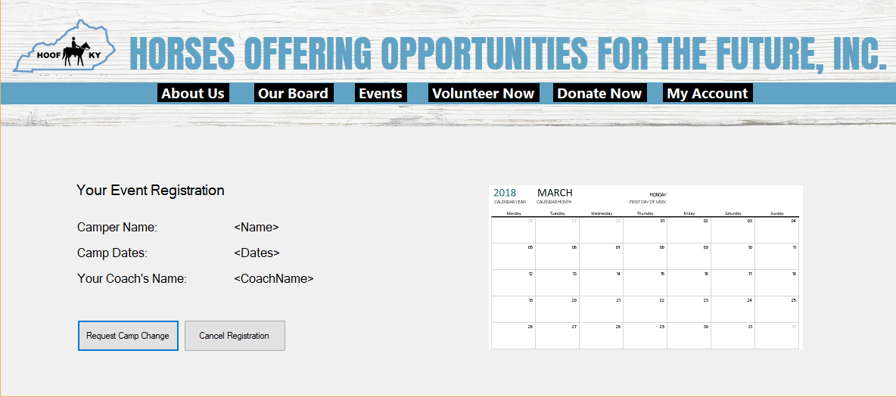

42: Creates File

This represents the screen where HOOF board members will upload files.

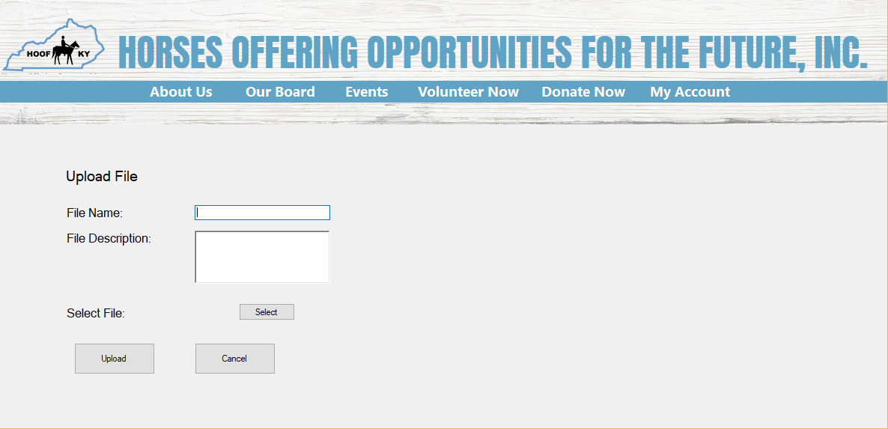

43. Modifies File

This screen allows the user to modify details for an already uploaded file.

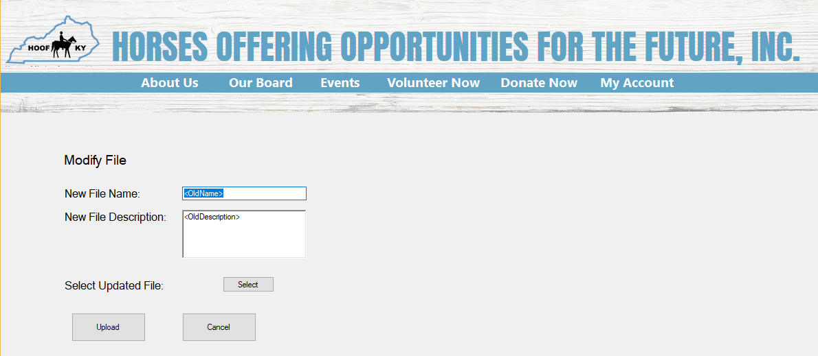

44. Deletes File

This shows the list of files, from which board members will be able to delete files.



45: Modify Auction Item

This represents what the item donor will see when they want to modify the details of an item they have donated to a HOOF auction.

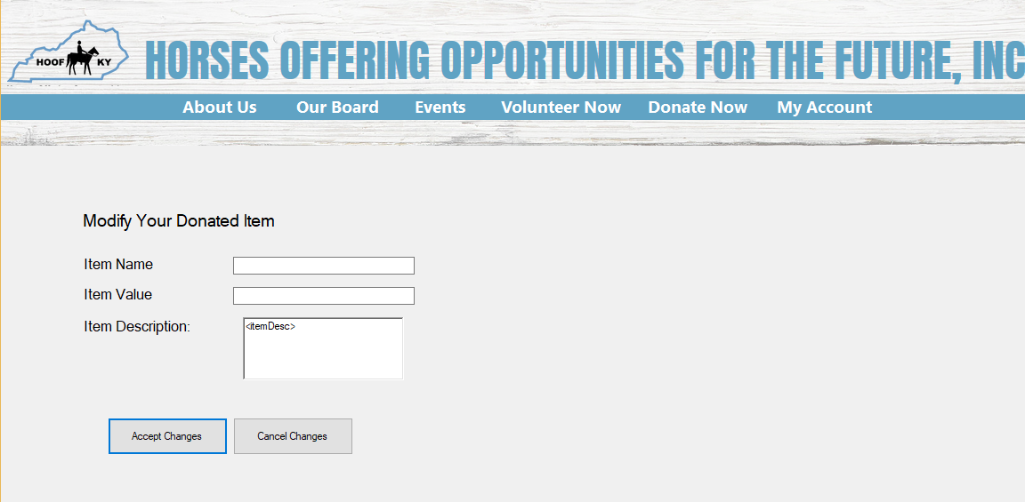

46:Delete Auction Item  
This shows the screen that will be present when an item donor decides to remove their item donation from the HOOF auction.

